SQL Case Study

# Adventure Works data Set

BUSINESS CONTEXT:

Data Availability: The data set we will be using for our session comprises of 3 tables:

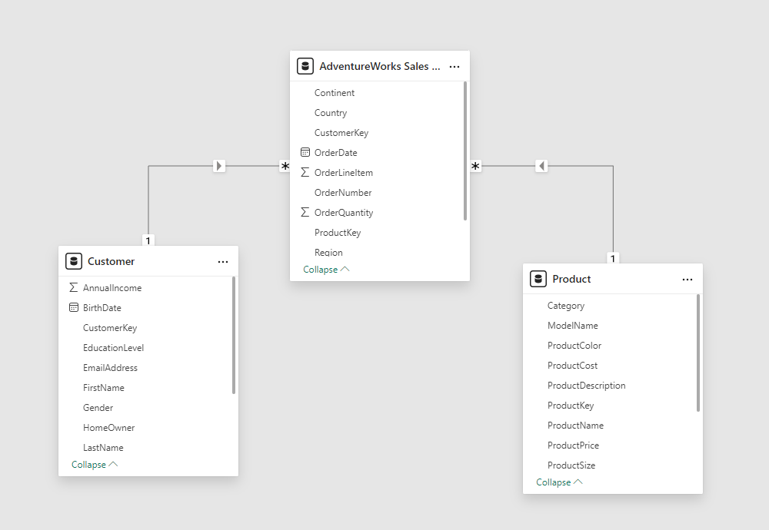

The following diagram explains the relationship between tables:

1. Adventure Works Sales Data: Details of Sales (Fact Table)
2. Customer: Details of Customers (Dimension table)
3. Product: Display of Products (Dimension Table)

You can find the Data Set Below

( <https://docs.google.com/spreadsheets/d/1JI0F-Dz5RawTIyDfWz_cd5KSNgDTITaX/edit?usp=sharing&ouid=101732815729596760060&rtpof=true&sd=true> )

Problem Statements:

1. Retrieve the top 5 customers who generated the highest profit for the company.
2. Identify the top 10 most profitable product categories.
3. Calculate the average sales per customer for each region.
4. List the top 5 cities with the highest average profit per order.
5. Display the total sales and profit for each product subcategory and region, excluding orders where sales were less than $1000.
6. Calculate the average profit per order and the percentage of orders that were returned for each category, excluding orders where sales were less than $100.
7. Retrieve the total sales and profit for each subcategory and brand combination, considering only orders that were not returned and were made by customers in the East region.
8. Retrieve the total sales and profit for each brand in each product subcategory.
9. List the top 10 states by total sales, excluding orders that were returned.
10. Retrieve the top 10 customers with the most returns, along with the total value of their returns.Top of Form

Bottom of Form

**Notes for SQL Case Study:**

* **Join Operations**: You will need to join tables such as Adventure Works Sales, Customer, and Products based on keys like CustomerKey, ProductKey, and OrderNumber.
* **Aggregation Functions**: Use aggregation functions like SUM(), AVG(), and COUNT() to calculate total sales, average profit, and number of returns.
* **Filtering**: Use WHERE clauses to exclude orders based on criteria such as sales below $1000 or orders that were returned.
* **Sorting**: Use ORDER BY to rank customers, states, or cities based on their total sales or profit.
* **Grouping**: Use GROUP BY to group results by columns like Region, Category, or Subcategory to perform aggregate calculations.